These are the questions that need to be answered, please use complete sentences and proper grammar in your words.

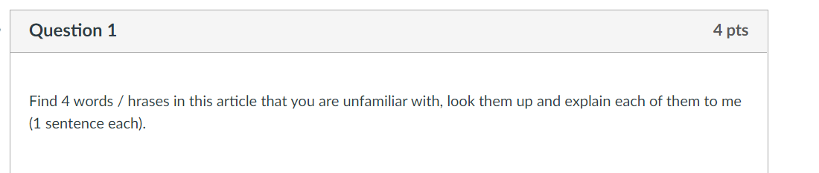

Drimane-type Sesquiterpenes
Non-nucleophilic bases
Swern Oxidation
Dimerization process
Drimane-type sesquiterpenes is a large family of natural product with various oxidative spots around the drimane skeleton.
Non-nucleophilic bases are aprotic solvents, they are strong bases but poor nucleophiles. An example is disopropylethyamine.
Swern Oxidation is an oxidation condition that transforms alcohol 19 to natural product (-)-cinnamodial
Dimerization process is the joining of two cinnamodial monomers to form a dimer.

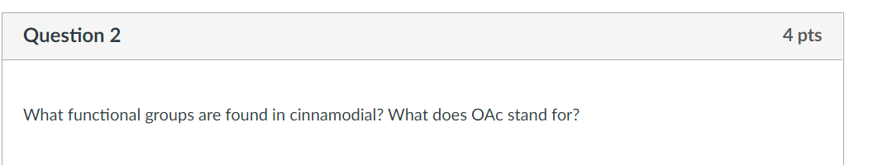

There are 3 functional groups found in Cinnamodial. These are Hydroxly
Methyl and Acetoxy
OAc stands for Acetoxy

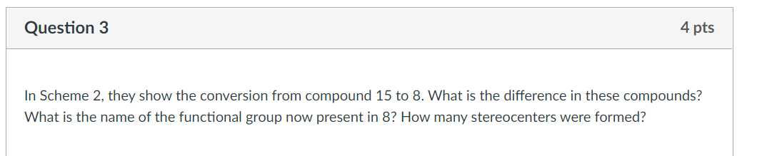
The difference between compound 8 and compound 15 is that compound 8 has an oxidative spot that compound 15 lacks. In the total synthesis of (-)-Cinnamodial from capsicondrenin, compound 15, tetrasubstituted olefin, has undergone epoxydation with mCPBA. In this reaction, it forms a diastreomer in 93% yield.
The functional group that is present in 8 is known as trimethylsilyl
Two Stereocenters were formed in this reaction

